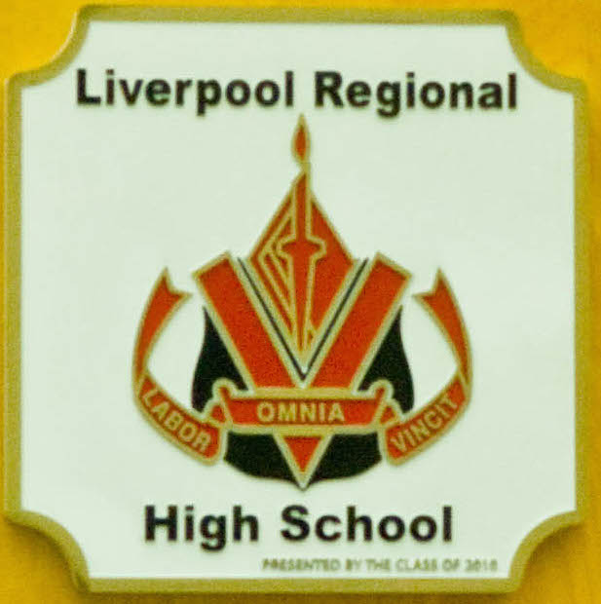
Liverpool Regional High School
Visual Arts 10 with Mrs. Erika Kirk
Email: emcmahon@nspes.ca
Course Website: http://erikakirk.weebly.com
School Phone: 902-354-7600

Course Goals:

Visual Arts 10 is a dynamic, hands-on course, which will include classroom assignments, projects, group work, practice, and public display of works created. You will employ a range of artistic styles, tools, and concepts to create a wide range of original art works. You will explore your own identity, aesthetics, art history and theory, and various techniques that make up your visual culture.

Creating art is a process in which the development of your technical skills, thinking skills, and idea/vision combine to create a final product. For most artists, the process has as much, if not more, value that the final product. Not all your artwork will satisfy you, but if you pay attention to what you did well and what you need to work on, your artwork will improve. As such, it is not the aim of this course to turn you into an artist, but to expose you to the thinking and creative processes of art, to help you expand your mind through an appreciation of the value of art in society, and give you an outlet for your own creative process.

Units of Study:

Elements and Principles of Design Drawing
Color Theory and Value Perspective
Clay Print Making
Papier Mache Sculpture
Painting Group Art
Research Project – Art History and Classics

Assessment…

Assessment of Art is an ongoing process. Assessment occurs in class with most assignments including a detailed rubric of criteria. Projects are evaluated on your willingness to explore a medium. Your performance is measured by whether or not you meet the criteria of an assignment and the degree of effort you displayed.
** Due to the hands on nature of the course, attendance is vital to your success. Please review the Attendance Policy in your student handbook.

…and Evaluation:

Studio Projects – 60%
Includes studio studies, final artwork and reflections on your art, art history presentations, and contribution to critiques/discussions. Class attitude is an essential part of success in Visual Arts 10. Willing enthusiastic students who show a positive work ethic and constructively participate will be successful.

Sketchbook – 20%
In-class art exercises, class notes, technical notes & samples, title pages, project research, creative thinking and independent explorations, written evaluations, artistic explorations, etc.
** Sketchbooks will be collected regularly for evaluation.

Final Project – 20%
At the end of the course you will be assigned a final project that will ask you to demonstrate and incorporate the skills, techniques and theory we have practiced over the semester. This project is in place of a final exam. ** There is no final exam in Visual Arts 10.

Assignment Due Dates:

Students will be given assignments that are reasonable and suited to their learning strengths and needs. As such, student assignments are to be passed in on the prearranged due dates that have been determined by the class.
** Late work will not be accepted after that assignment has been marked and returned to the class. Arrangements must be made prior to an assignment due date in order for you not to be penalized. It will be your responsibility to ensure you have passed all assignments in.

Materials Needed for the Course:

- Pencils/Pens
- Eraser
- Coloured Pencils and Markers
- Glue Stick
- Scissors
- Ruler
- 1 package of 8 ½ x 11” plain white paper
- Sketchbook – Will be provided by Mrs. Kirk. Your sketchbook will be used as your binder – please bring it to every class.

Communication with Home
(Please share this information with your parents)

General methods of communication, report cards, Power Teacher and other website information are all outlined in your child’s Student Handbook and online at http://www.lrhs.ednet.ns.ca. You are encouraged to read these documents carefully and make use of the information.

In addition, I strongly encourage you to contact me at any time you wish to find out how your child is progressing in this course, or if you have questions or concerns. Your child will also need to find out material or assignments missed during an absence, as missed days will result in lost marks if the work is not made up or passed in upon the student’s return to school. In this regard it may be useful to have my email or website address at hand so that students can keep up to date on assignments. Alternatively, students may also use each other as resources – it is helpful to have the telephone numbers of several classmates that they feel comfortable contacting in case they can’t reach me. Always remember that I respond on a regular basis to emails, so please take advantage of this means of communication when outside of school if possible.

Parent Signature: ________________________________

Date: __________________________________________

Expectations of Your Best:

- Students are responsible for attending class, doing their best work and meeting all deadlines.
- Respect the classroom space, materials and the projects of others. The Visual Arts room is not a traditional classroom environment - materials and projects will be left in use and in progress. Therefore, respect of classroom materials and your own work, as well as for the work of others, is expected.
- Students are responsible for catching up on any work they miss due to absences. I am available before school, at recess, lunchtime and after school if you need help getting caught up or have questions about assignments. See me to set up a meeting time.
- Copyrighted imagery or plagiarized work from the Internet or any other source will result in having to redo the assignment, a call home and possibly an office referral.
- Students are responsible for coming to class prepared – physically (your sketchbook, pencils, etc.); mentally (yes, you have to think and be ready to do it!); and emotionally (have yourself in order if need be and focus on the task of the hour – learning).
- No locker visits or washroom breaks will be permitted during class time. Make a point of being on time; that is, going to your locker or the washroom before or after class.
- Students need to develop the habit of taking notes on what is said, written or seen.
- Students may have the privilege of using Mp3 players during individual work only; otherwise they are not to be visible or heard. This privilege will be revoked if it is abused.
- This is a cell phone free zone. I am not to see a cell phone out in class for any reason. If I do I will take it for the remainder of class time. If you are a repeat offender, I will take your phone and give it to administration and you can get it from them. If for any reason you have your phone on during class time, please discuss it with me one on one before class starts.

