http://dramaresource.com/strategies/tableaux

Image Theatre
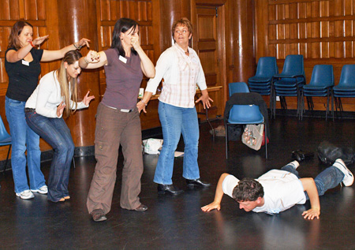
In Image Theatre, still images are used to explore abstract concepts such as relationships and emotions, as well as realistic situations. This technique was developed by Augusto Boal and is described fully in his book The Rainbow of Desire.
Participants rapidly sculpt their own or each others' bodies to express attitudes and emotions. These images are then placed together and 'dynamised' or brought to life. The method is often used to explore internal or external oppression, unconscious thoughts and feelings.
Why use it?
Image theatre is a flexible tool for exploring issues, attitudes and emotions both with groups who are confident with drama and those with little or no experience. No one has lines to learn or has to 'act' in front of others. Imaging can enable students to explore their own feelings and experiences in a less forbidding way than that offered by improvisational techniques.
How to do it
In a circle, students create physical images in response to a given theme, for example, bullying. They should do this quickly, without pre-thought. They are then invited to step into the centre of the circle and remake their image. Other students can now add in their own still images. This could lead to an abstract group image or a tableau that is “dynamised” or brought alive through thought tracking or by adding sound or movement.
Pairs or small groups can also create their own images, where they take it in turns to “sculpt” each other into a shape and then find a way to put these shapes together. This is most effective if done without talking.

Tableaux
What is it?
In a tableau, participants make still images with their bodies to represent a scene. A tableau can be used to quickly establish a scene that involves a large number of characters. Because there is no movement, a tableau is easier to manage than a whole-group improvisation – yet can easily lead into extended drama activities. It can be used to explore a particular moment in a story or drama, or to replicate a photograph or artwork for deeper analysis.
How do you do it?
Students stand in a circle, or around the performance area and a theme is given. One by one, they step into the space and establish still images in relation to one another until the tableau is complete. At this point, thought tracking can be used to find out more about each of the characters. The scene can also be brought to life through improvisation, with the teacher clapping her hands to signal the beginning and end of the action.
Once students are familiar with the technique, they can also work in small groups on different aspects of a theme. The class can discuss each group’s tableau in turn, mentioning what they can see happening, what they would like to know more about and what they think could happen next. Afterwards, each group can comment on how these viewpoints compared with their initial intentions.
Examples
  - Pupils look at a painting or illustration of a historical scene that shows a selection of different characters. They bring it to life by representing the characters with their bodies.
  - Current Affairs/History: Small groups are given different newspaper reports of the same incident (or differing accounts of an historical event) and asked to produce as accurate a tableau as possible. This can be used to examine how events may be communicated differently according to the observer’s point of view.
  - For a more light-hearted activity, groups can devise a tableau on a specific theme, such as epic books or movies, famous locations or well-known historical events. The other students then try and guess what the tableau represents.

Still Images / Freeze Frames
Still images and freeze frames are both a form of tableau. With freeze-frame, the action in a play or scene is frozen, as in a photograph or video frame. Still images, on the other hand, require individuals or groups to invent body-shapes or postures, rather than freeze existing action.
Groups can be asked to tell a story through a series of prepared still-images. This can be an effective method for students who are less inclined to improvise dialogue. The still images can also be brought to life through improvisation. Freeze-frames and still images can be usefully combined with Thought Tracking, Forum Theatre or Flashbacks and Flash Forwards.
Examples
Still images provide one of the most flexible methods of working in drama. They can easily be used across the curriculum, for example:
- Groups can tell a story by using three images to create a beginning, middle and end.
- You can help to improve students' vocabulary skills by asking them to illustrate a word or phrase in a story using a still image.
- Fun can be had making group objects that turn from one thing into something else – for example Cinderella’s pumpkin turns into a coach, mice into horses, a rat into a coachman, and lizards into footmen.
- In Science, groups can develop a series of images showing the process of metamorphosis (e.g. caterpillar to butterfly or frogspawn to frog).

Thought Tracking
A group makes a still image and individuals are invited to speak their thoughts or feelings aloud - just a few words. This can be done by tapping each person on the shoulder or holding a cardboard 'thought-bubble' above their head. Alternatively, thought tracking (also called thought tapping) can involve other members of the class speaking one character's thoughts aloud for them. The technique is most often used in conjunction with image theatre or freeze-frames. Equally, thought-tracking is useful preparation for improvisation.

