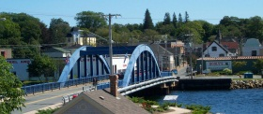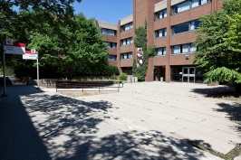**10**

32 – Remarried to Mr. Kirk

26 – My son is born

18 – Moved to Toronto to start university

Mrs. Kirk’s Personal Timeline

30 – Moved home to Liverpool

24 – Hired to run Winter’s Residence – alma mater

20 – Got into Teacher’s College





34- Ran first half marathon

**0 18 20 22 24 26 28 30 32 34 36**



22 – Graduated from University – friends moved away

[](http://www.google.ca/url?sa=i&rct=j&q=&esrc=s&frm=1&source=images&cd=&cad=rja&docid=3Gtvry7hOWalQM&tbnid=zfLo2kq4kH3-7M:&ved=0CAUQjRw&url=http%3A%2F%2Fwww.wallpaperswala.com%2Fbest-friends%2F&ei=0LBuUtzrG8qwygHV3oCgBg&bvm=bv.55123115,d.aWc&psig=AFQjCNFE3PwJE7hyAQbMHAkMzZ6cc-Rsrw&ust=1383072305451878)

25 – Left Toronto – moved to NFLD

****[](http://www.google.ca/url?sa=i&rct=j&q=&esrc=s&frm=1&source=images&cd=&cad=rja&docid=JQqUCQ-Y1OtrcM&tbnid=Pt7Yd7txsq7udM:&ved=0CAUQjRw&url=http://www.thestar.com/life/travel/2013/04/23/newfoundland_travel_a_great_opera_festival_and_tips_on_how_to_see_st_johns.html&ei=RbFuUuKGBaPmyQGam4GwCg&bvm=bv.55123115,d.aWc&psig=AFQjCNFUkLgNw4JZmF0LO2Xm5KLrK7k2uQ&ust=1383072413078680)

**-10**

28 – Got divorced