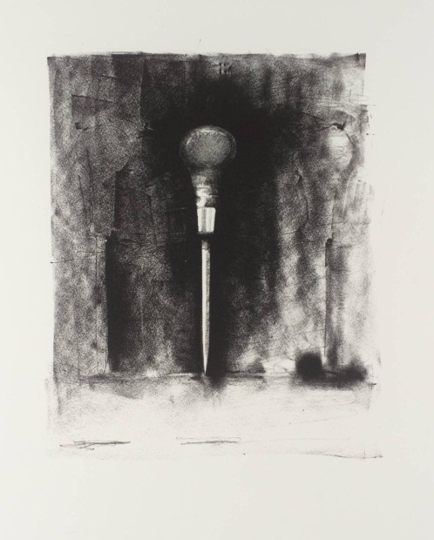
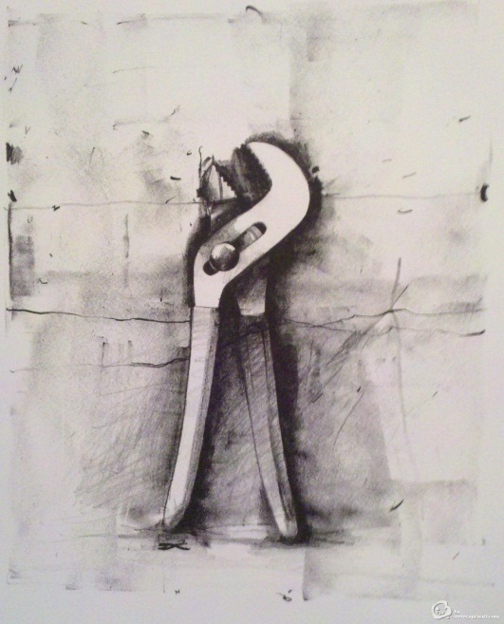
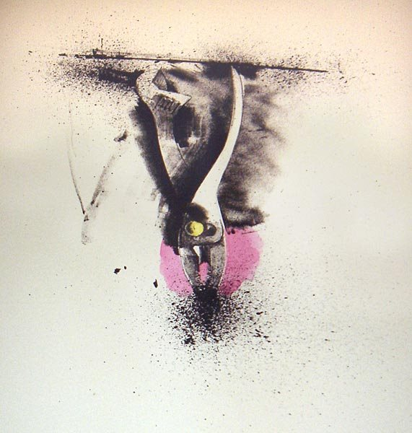
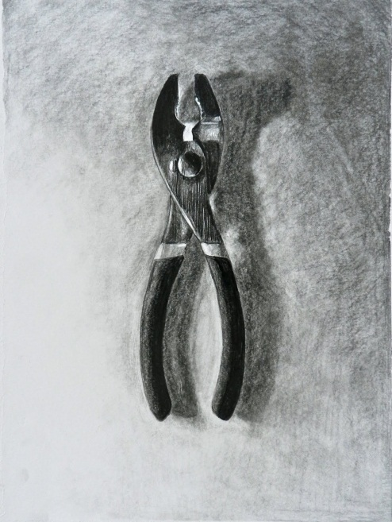
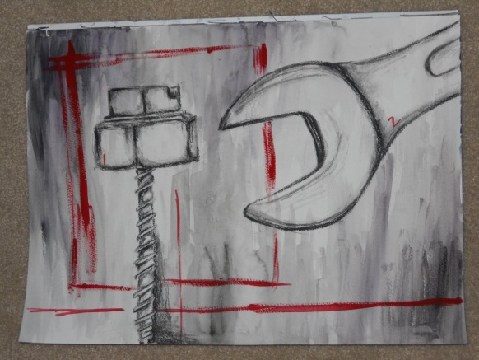
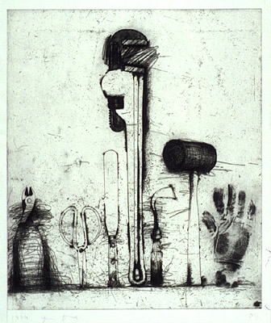
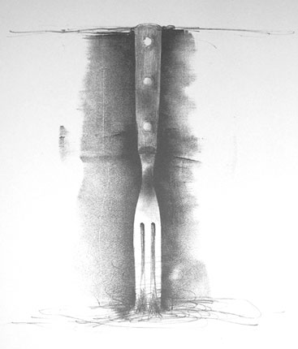
Examples of Jim Dine style Tool Drawings

Jim Dine Tool Drawing Assignment Rubric Name: _______________________

This assignment is due on: ________________________________________

Criteria | Value | Comments
Format: You picked the best format from your thumbnail sketches to capture the detail of your subject. You accurately labeled the format chosen on your final work (Close Up, Cropped, (Monumental, Intimate, Life Size, Floating/Falling in Space). | 1 2 3 4 5 6 7
Composition: Where you chose to place the subject on the page enhanced the representation of the subject in your work (Vertical, Horizontal, Dominant, Floating) | 1 2 3 4 5 6 7
Scale: The scale you chose enhanced the representation of the subject in your work (Big, Small) | 1 2 3 4 5 6 7
Focal Point: Where you want the eye to look and for how long is clear in the representation of your subject. Detail work has been finished and image is complete as a whole. | 1 2 3 4 5 6 7  8 9 10 11 12 13 14
Figure/Ground: How the subject relates to the background best represents the subject of the drawing and supports focal interest. | 1 2 3 4 5 6 7
Value: A variety of methods to create value are used effectively. | 1 2 3 4 5 6 7  8 9 10 11 12 13 14  15 16 17 18 19 20 21
Total |  | / 63 = %

