Writing Warm Up

What does collaborative and productive group work look, feel and sound like?

Reading Strategy Stations

Curriculum Outcomes addressed:

Speaking and Listening –
9.3.1 – Demonstrate active listening and respect for others
Reading and Viewing –
9.4.4 – Use text features to construct meaning and understand the text
9.4.6 – Independently use a range of reading strategies to make meaning from complex print and media texts
9.4.8 – Reflect on own reading a viewing strategies and make necessary adjustments
9.6.1 – Go beyond initial response to give more thoughtful interpretations by questioning, connecting, evaluating and extending
9.6.2 – Support personal response to the issues themes and situations in texts and give personal examples
9.7.5 – Understand that values and personal experiences influence understanding and critical response
Writing and Representing –
9.8.4 – Use various forms of note-making for different purposes and situations

Group Work Expectations

Looks Like: | Sounds Like:

Anything else to add?

Work Examples and Expectations

At each of the stations I have provided you with all the materials necessary to complete the task given. With those materials I have provided an example of a “good” finished product of the task.

What might a “good” finished product look like?

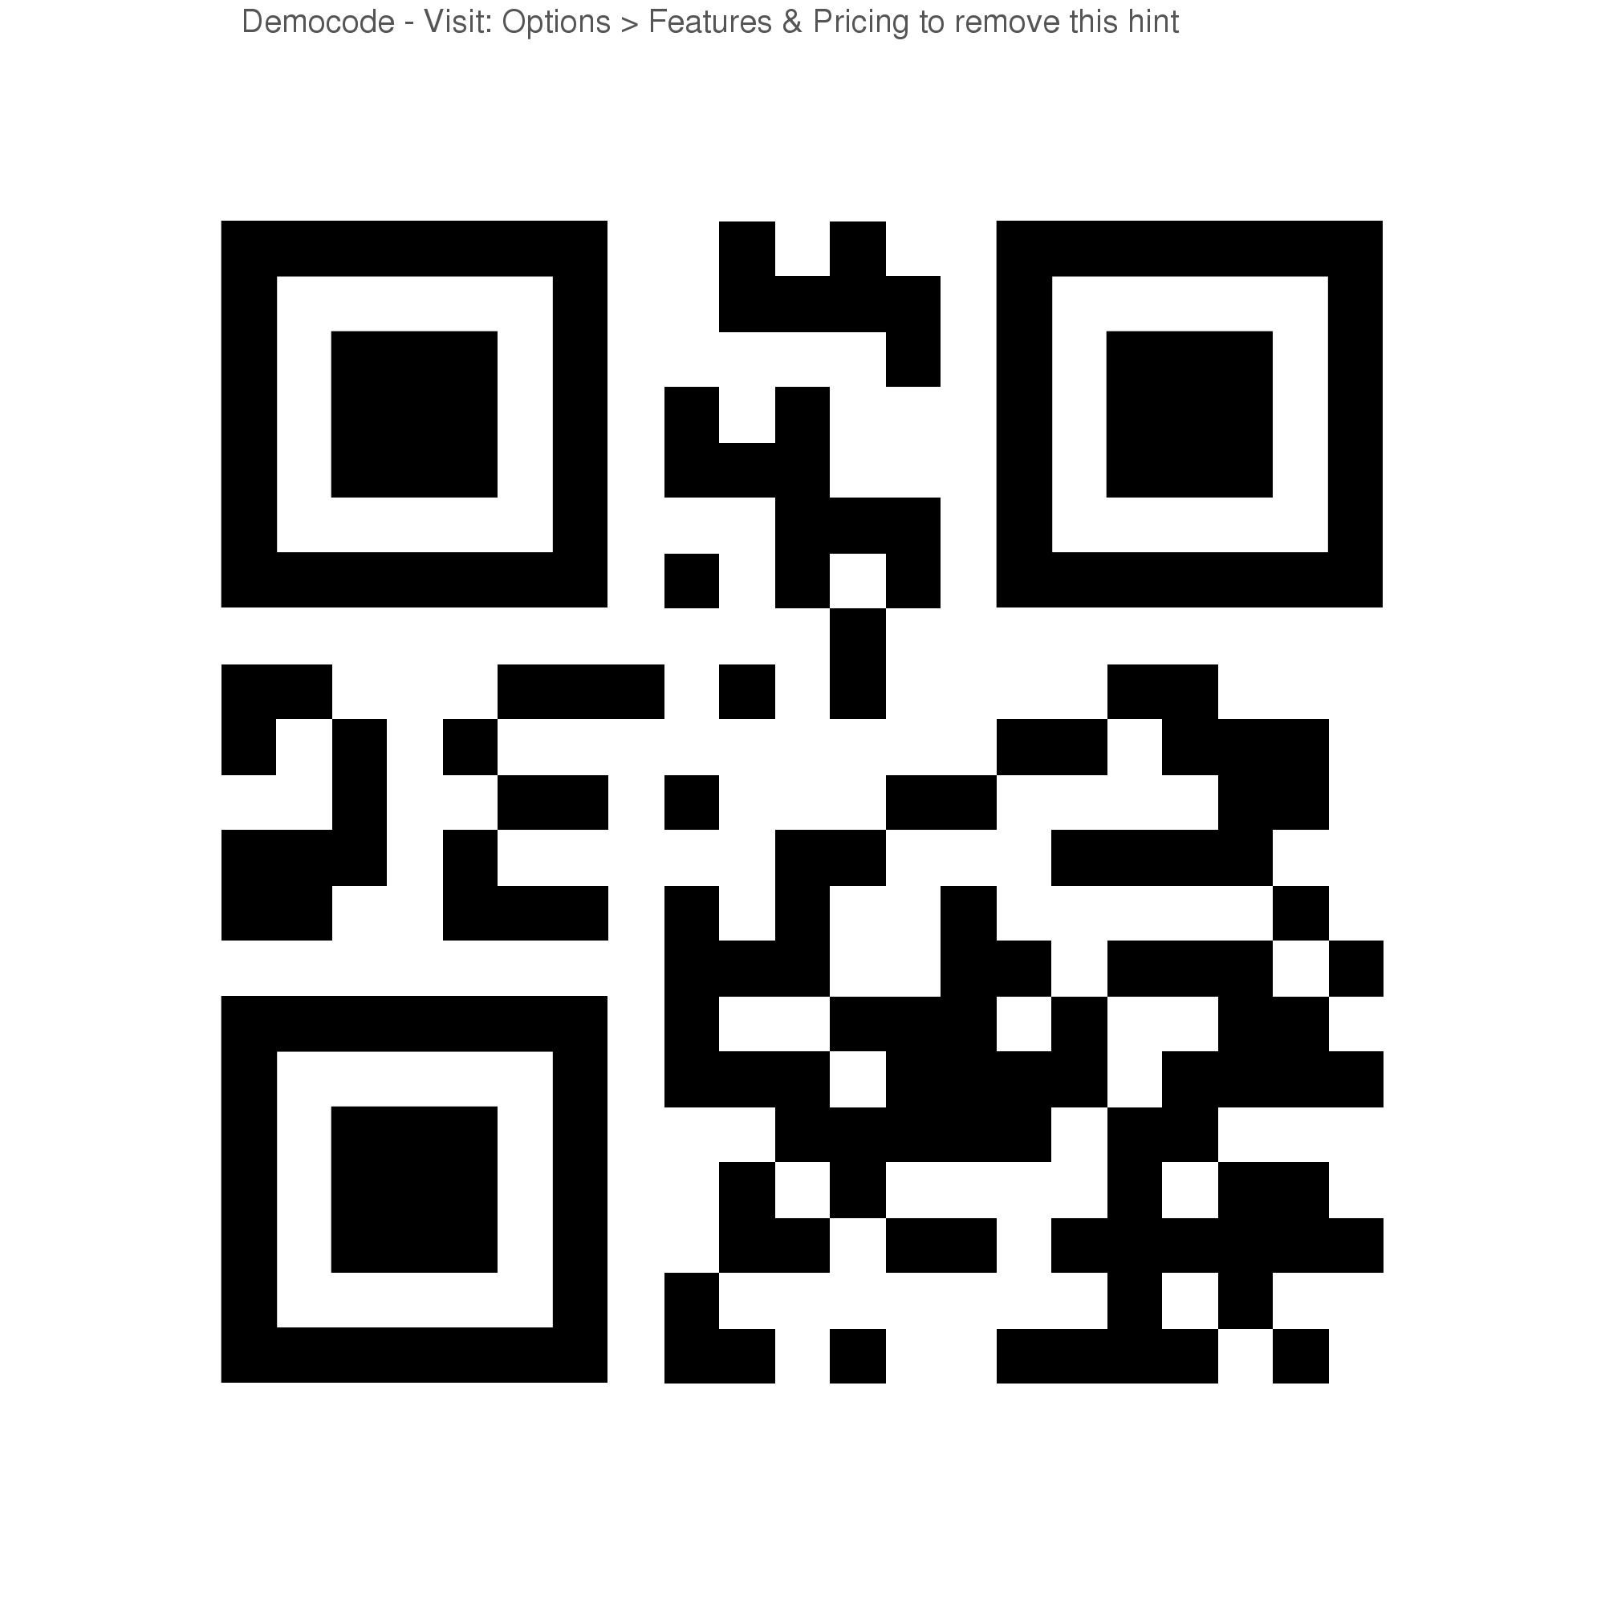
Scan for Reading Strategies Handout

Instructions and Timeline

- There are 9 Reading Strategy stations, and there will be 9 groups.
- I will number you all from 1-9. When I give the instruction to get into groups, you will partner up with people who have the same number as you. You should end up with 3 people in your group.
- Your group will go to one of the stations. Only one group should be at a station at a time.
- You will have 60 minutes to complete 2 stations. That means your group spends 30 minutes at each station. I will tell you when it is time to move on to the next station. You must move on whether you are finished the task or not.
- Each person in your group must complete their own sheets. You may help each other to get the work done, but it is your responsibility to make sure your own work is done. No Hitchhiking! Gas is not free.

- After your time is up, we will quietly return to our seats and discuss how the stations went.

Coding

When coding, you write your connection, inference, question, etc. in the margins of the text next to the quote that inspired the strategy use and record the type of reading strategy that was used.

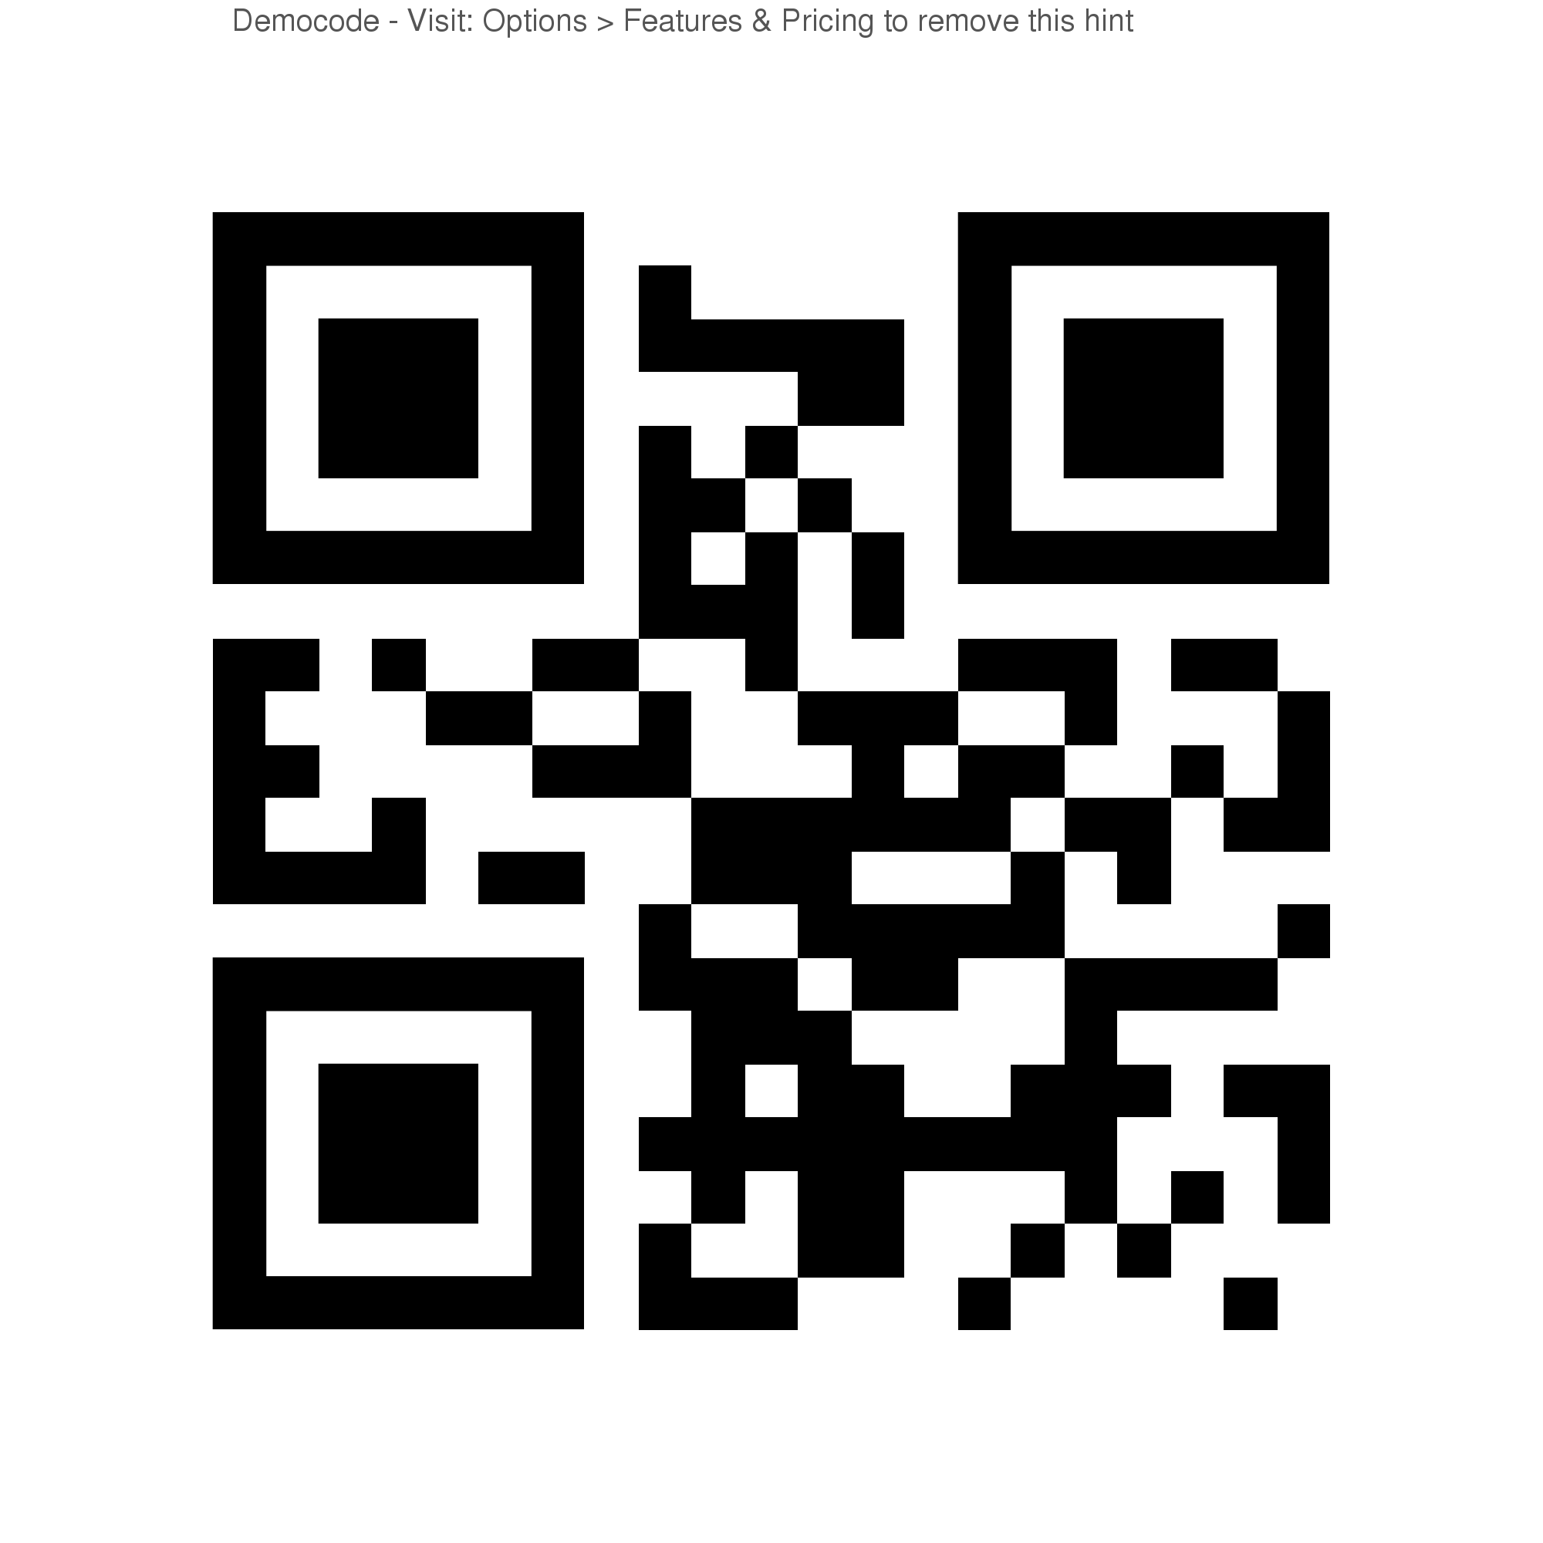
C – Connecting
I – Inferring
Q – Questioning
A – Analyzing
DI – Determining Importance
P – Predicting Scan for “The Custodian”
S – Synthesizing
V – Visualizing

Your instructions for this station:

- Look at the Example.
- Take a copy of the text “The Custodian”.
- Read it quietly to yourself and code it using the key above.

Sticky Notes / Trouble Marks

Sticky notes work the same as coding*, except that you write your strategy and strategy code on a sticky note, with an arrow pointing to the quote that inspired the strategy used. This is a good way to keep tabs on your thoughts as you read; because we often use school books we’re not allowed to mark in.

*Coding: When you write your prediction, connection, inference, question, etc. in the margin of your text next to the quote that inspired it. See coding station for details.

Alternatively, you can use a slip of paper (or sticky), and draw an arrow to a quote that is giving you “trouble” and place it in the book for future reference – when you can ask a peer or teacher what the quote means. Make sure you write what you think the quote means on your trouble mark and any strategy you used to try and figure it out.
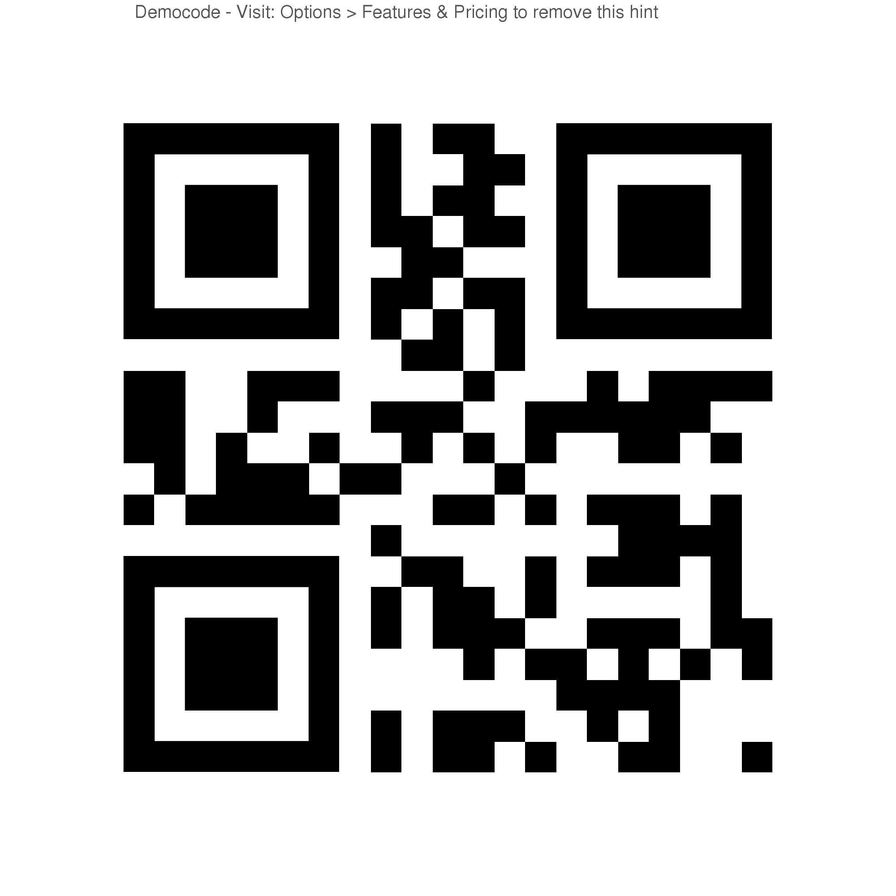
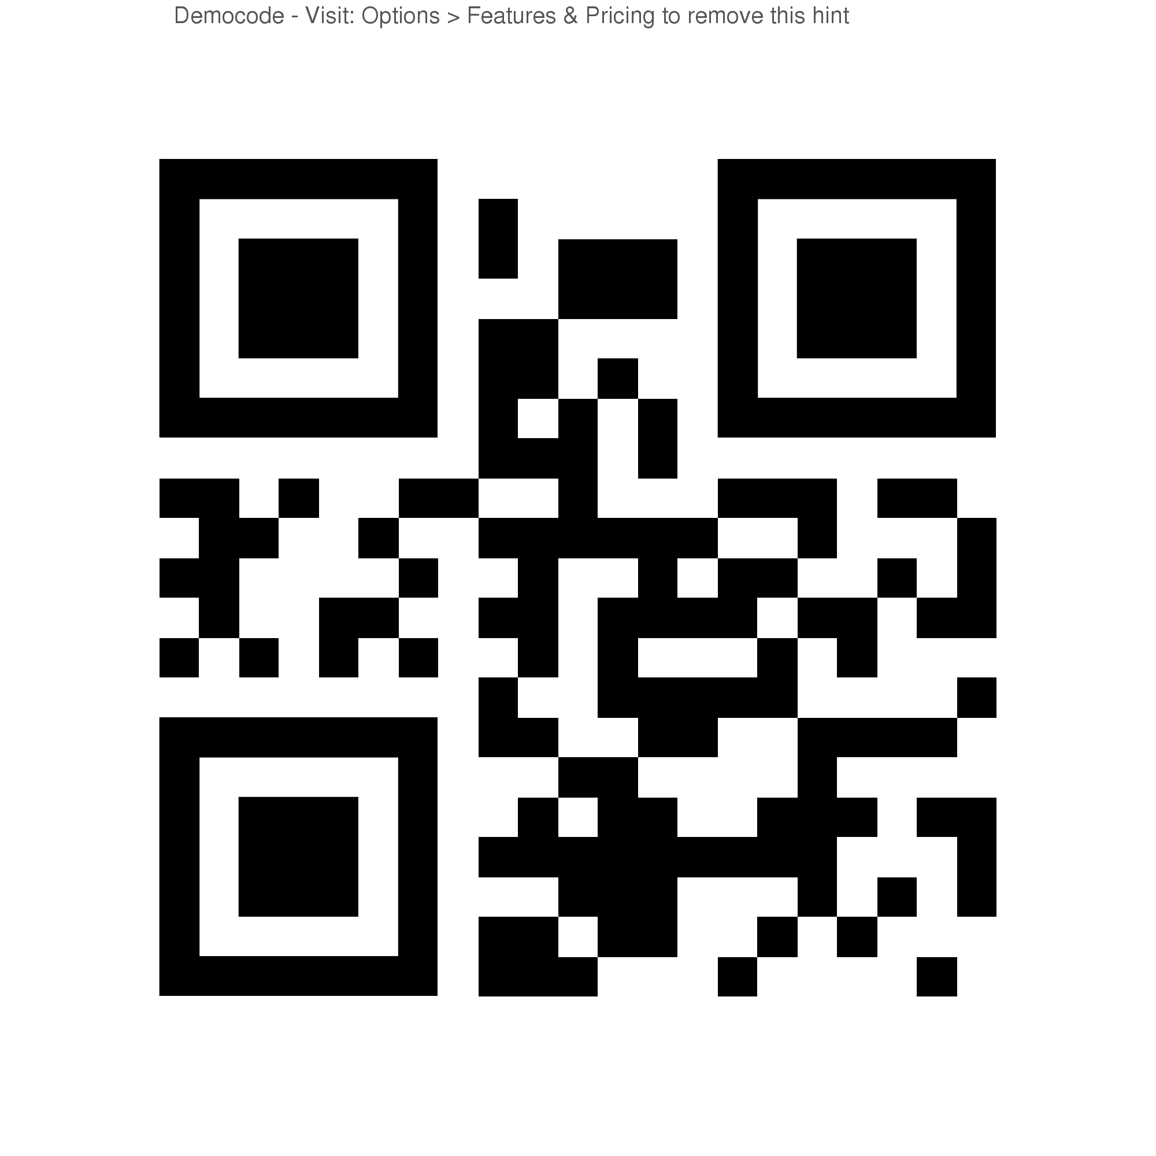
Scan for Scan for
Trouble Marks “Aero Bars”

Your instructions for this station:
- Look at the Example.
- Take a copy of the text “Aero Bars” by Robert Hilles.
- Read it quietly to yourself and
- Code it using sticky notes
- OR Create one “Trouble Mark” for a quote you don’t understand.
- You do not need to do both sticky notes and a trouble mark (unless you really want to).

Inferring

Inferring involves taking new information just read and incorporating it into your understanding of the world. After successful inferring, the world, or parts of it, should look a little different and you should be thinking about things in a different way.

Your instructions for this station:

Reflection / Reading Response

- After reading “Disney Is ‘Face Cloning’…” by Keith Wagstaff, on looseleaf write a response that describes how the new information just read has altered the way you see the world and your place in it.

- The response should be at least one complete thought, if not multiple. Use paragraph form please.

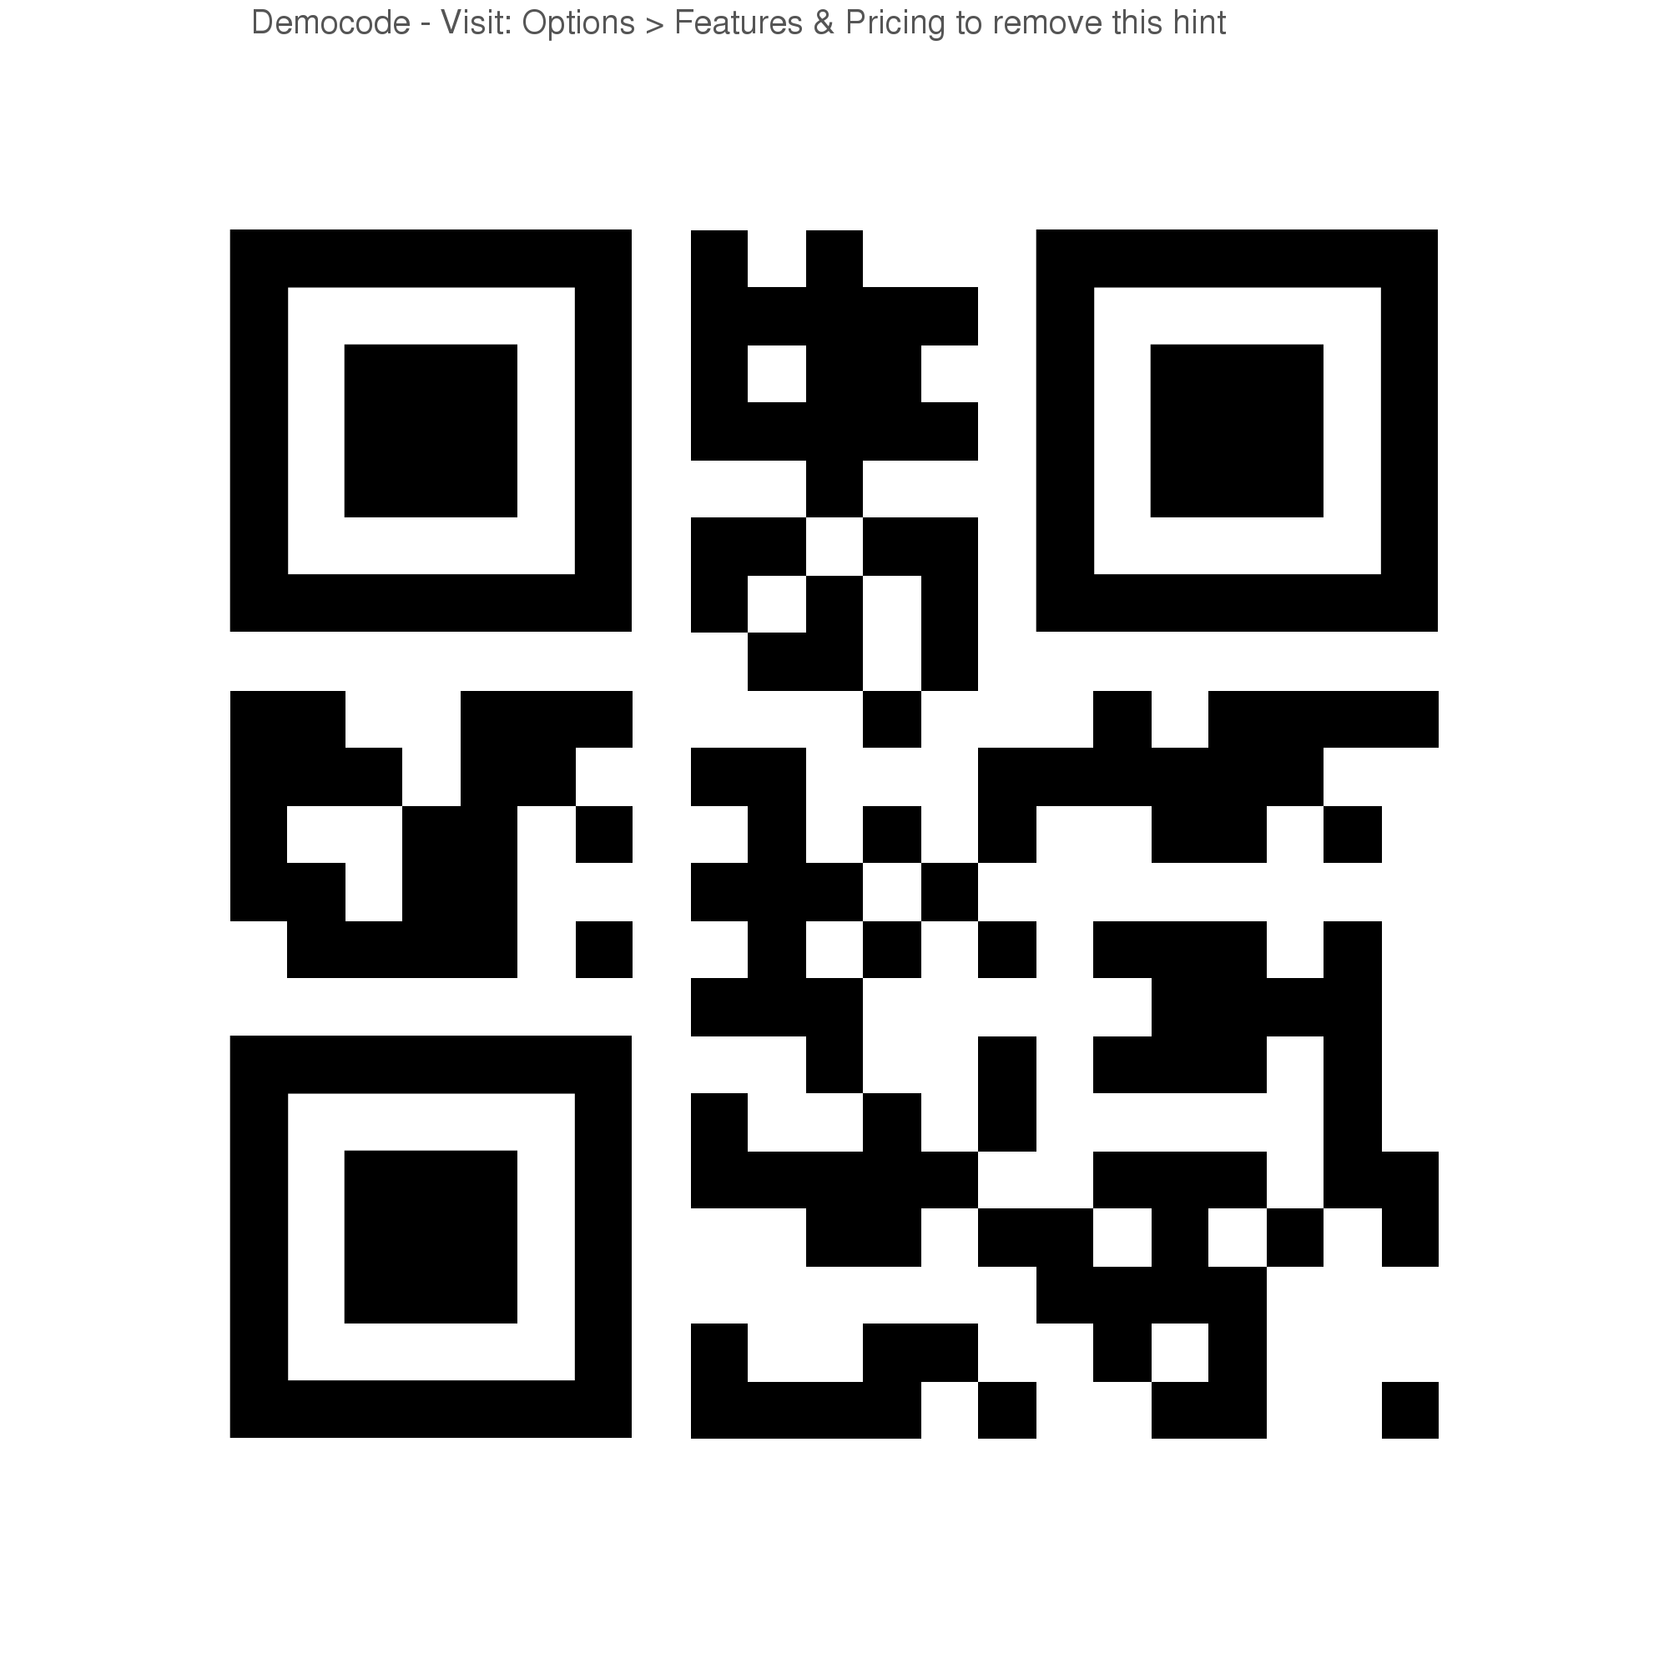
Scan for “Disney is Face Cloning” Article
S

Synthesizing

Synthesizing is taking multiple new pieces of information to form new understandings. It is similar to inferring, but instead of combining new information and background knowledge, you are combining multiple pieces of new information.

Your instructions for this station:

- Examine the contents of this person’s backpack. What kind of person would have these items in their backpack? Remember to combine the multiple sources of new information you receive with each other.

- Write a description of the owner of the backpack and what kind of person you think they might be on a piece of looseleaf. Use paragraph form please.

Questioning

Your instructions for this station:

- After you have finished reading “Conversation Piece” by Ned Guymon, create questions on the Question Flood graphic organizer using the prompts.

- You are not supposed to know the answers to these questions.

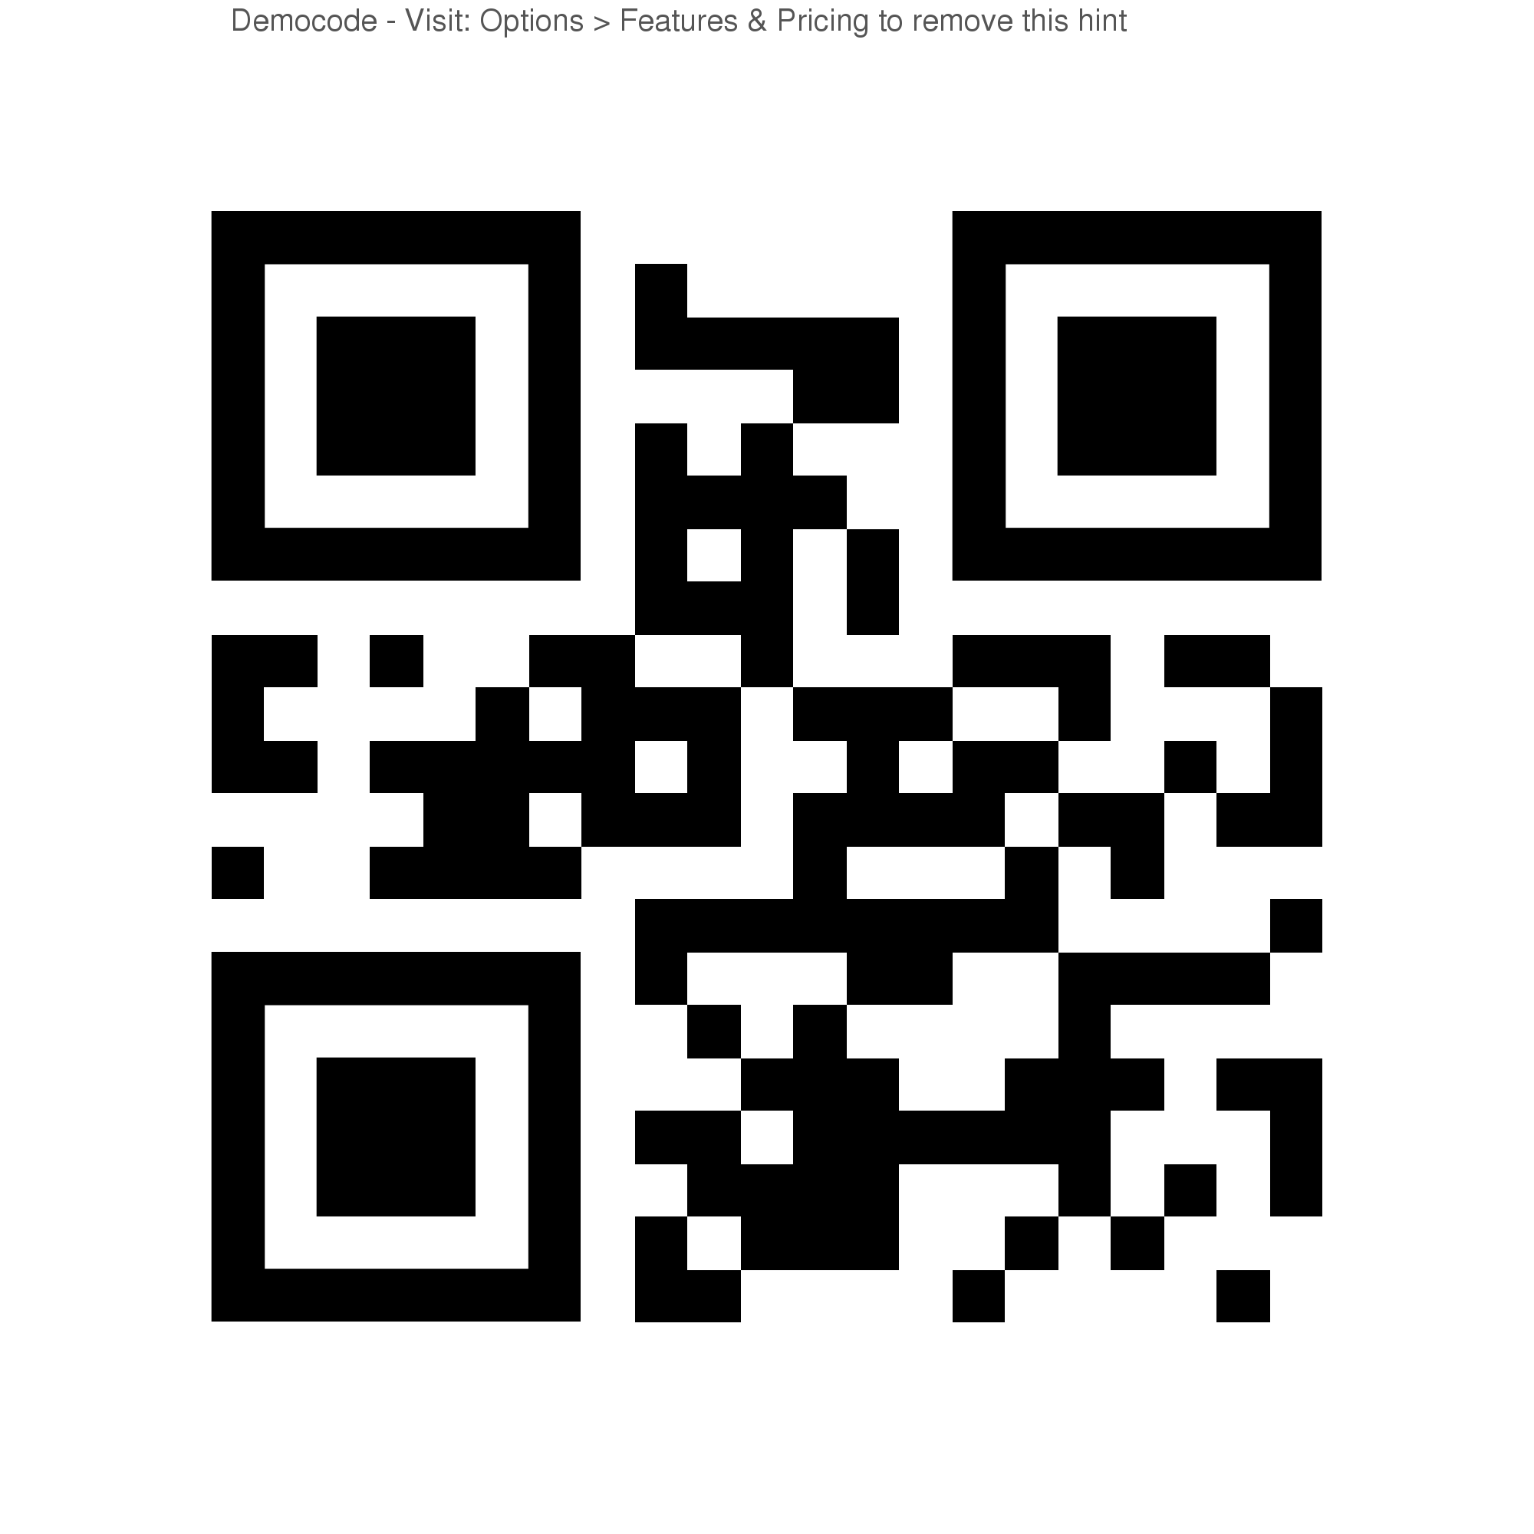
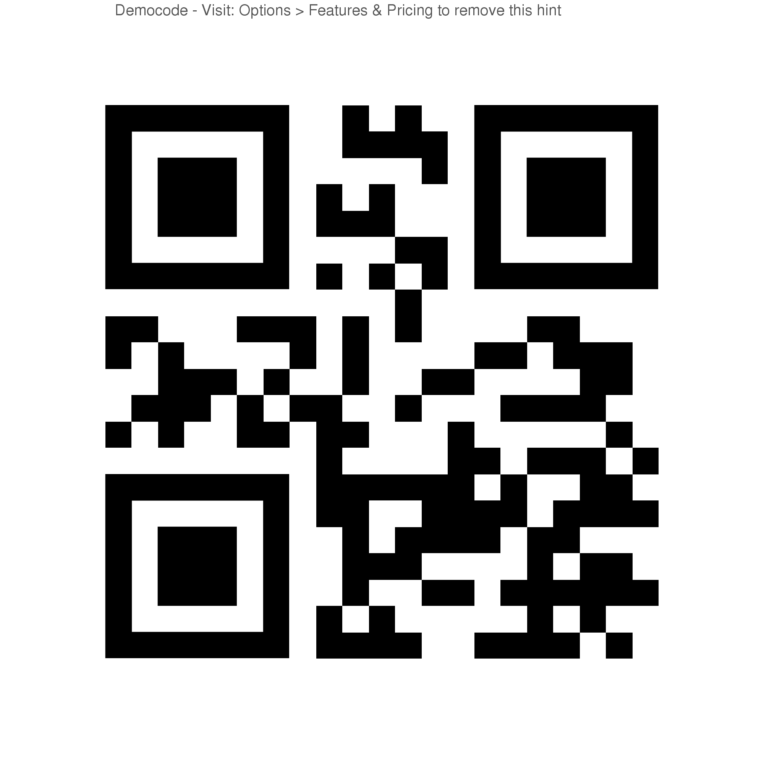

Scan for Question Flood Handout Scan for “Conversation Piece” text

Question Flood

Question | To whom are you asking the question? Ex. Author, narrator, character, teacher, peer
Who
Who
Who
Where
Where
Where
When
When
When
What
What
What
How
How
How
Why
Why
Why

Visualizing

Your instructions for this station:

- Read the opening to A Raisin in the Sun by Lorraine Hansberry.

- On the blank paper provided, draw what you have visualized as you read.

- If you have no artistic skills, you may simply visualize the scene in your head and describe it (using LOTS of adjectives) to your peers.

- If you are more of a performance artist, you and your group can recreate the scene using drama.

Scan for “A Raisin in the Sun”
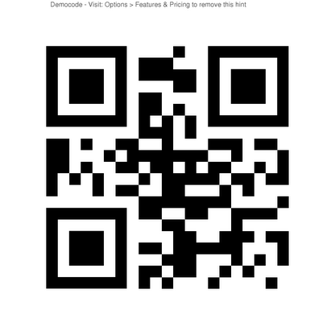

Inferring/Connecting

Your instructions for this station:

- Look at the Example.

- After you have finished reading “Fingers” by Gary Gildner, complete a Double Entry Diary on the sheet provided.

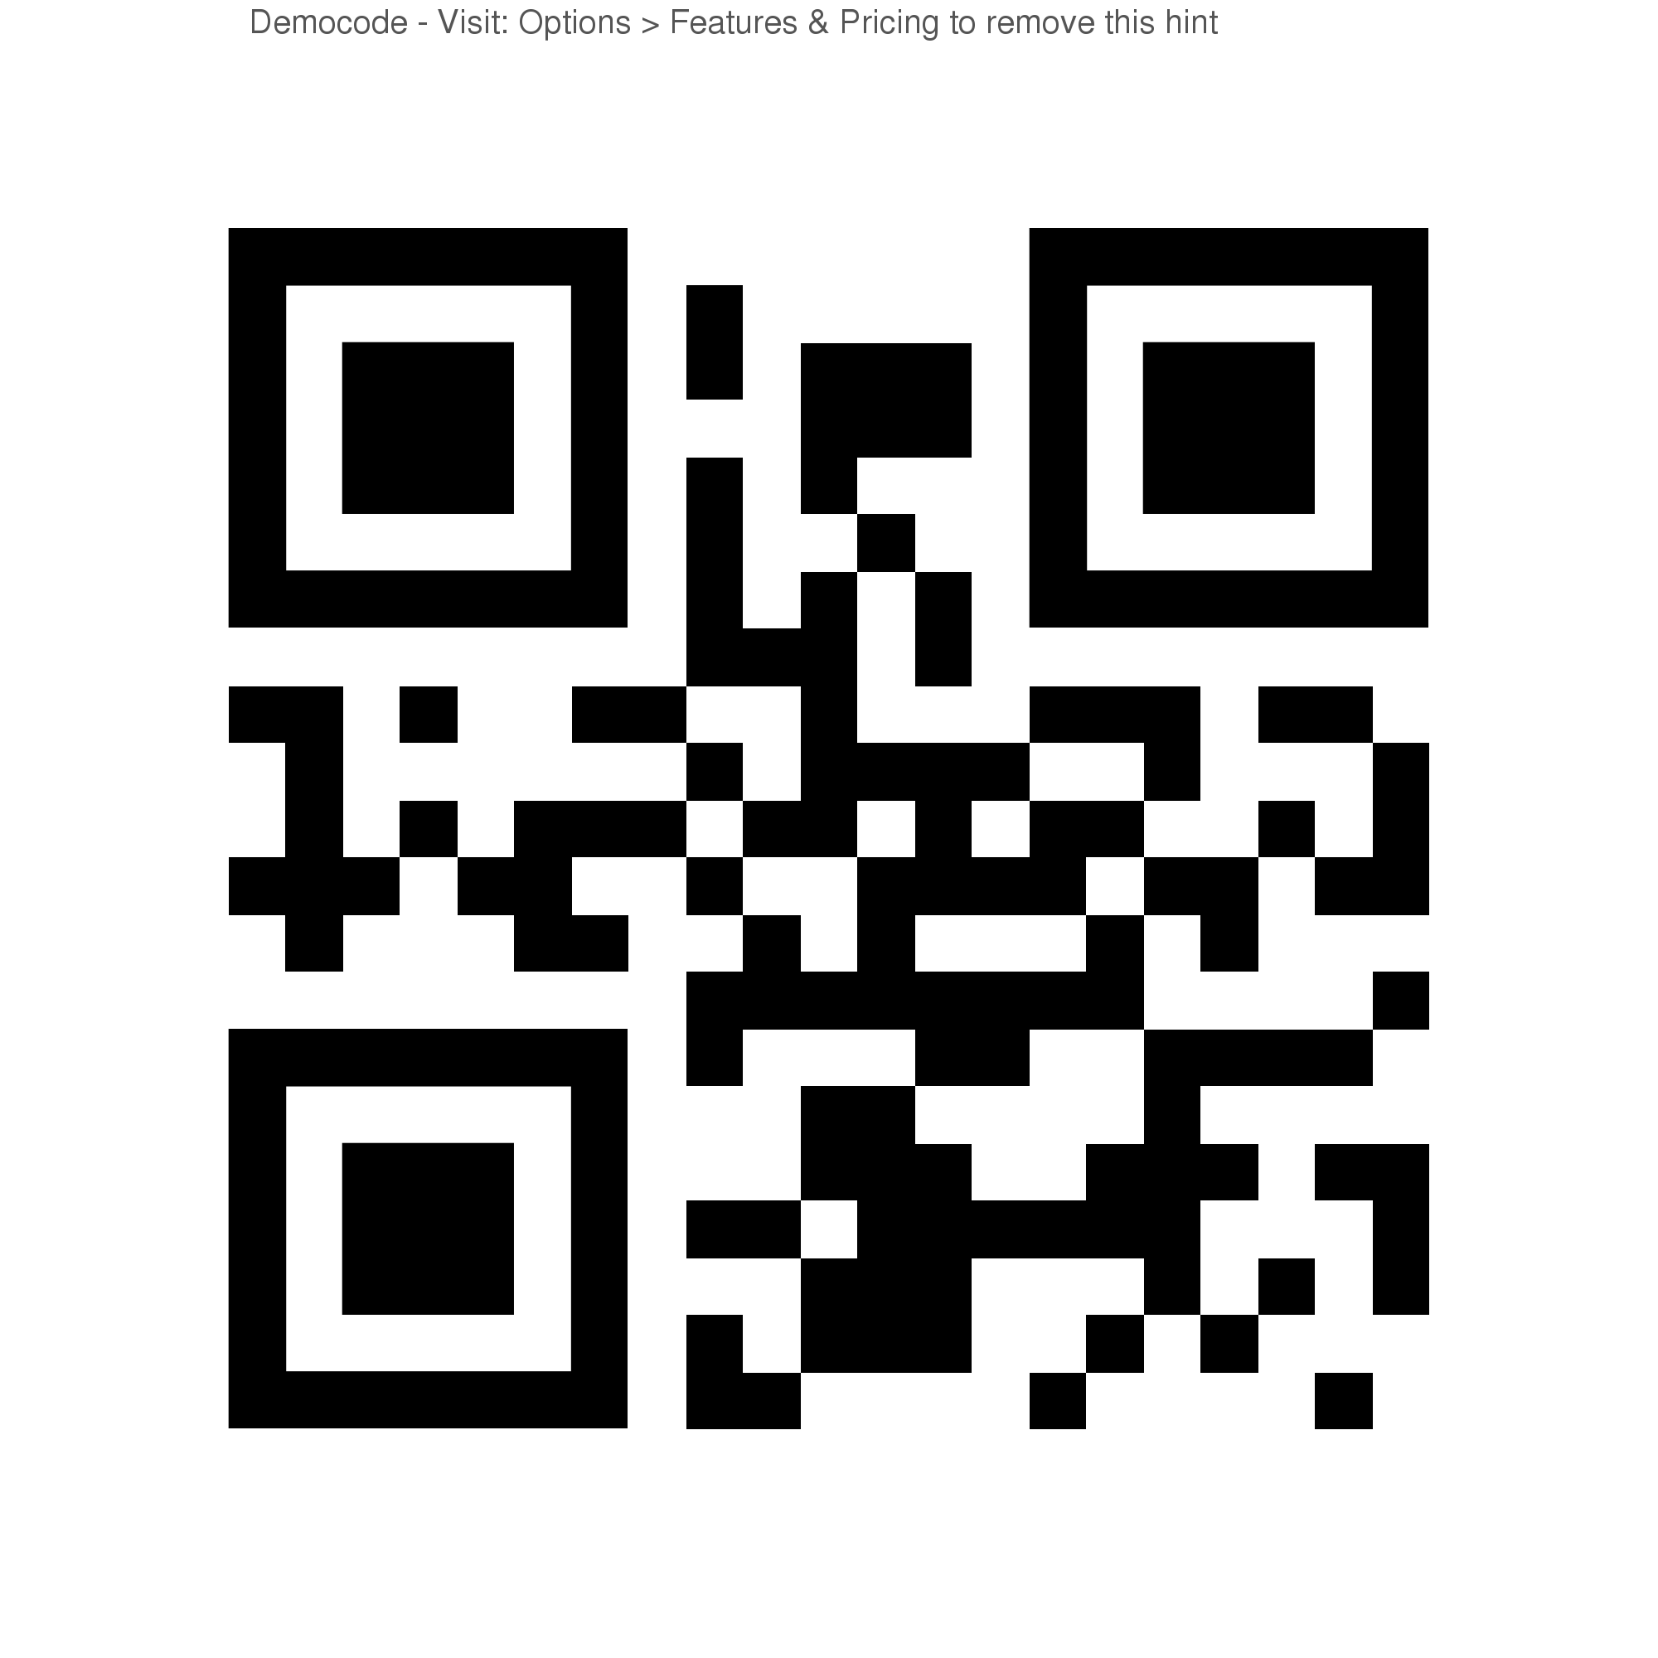
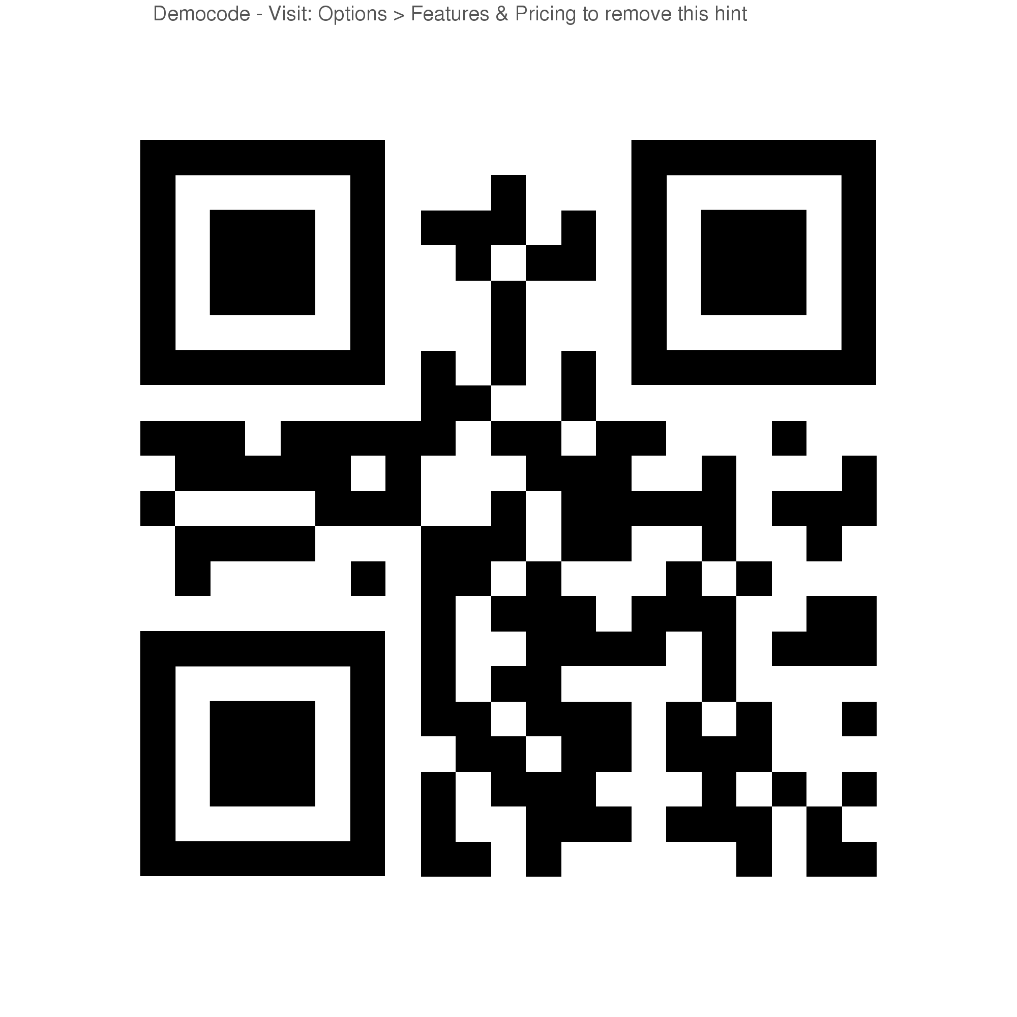

Scan to get the text Fingers Scan to get Double Entry Diary

Double Entry Diary
Quote from the text that made me think… | Inference or Connection
I think this means…
The author is suggesting that…
The hint in this quote is…
This reminds me of when I read…
This reminds me of the time I…
This reminds me of how…

Predicting

Your instructions for this station:

- Look at the example first – you will complete the handout as you read the text. (This won’t work if you read the book first!)

- While you read “Richard Wright and the library card” by William Miller, complete a Prediction Map on the sheet provided.

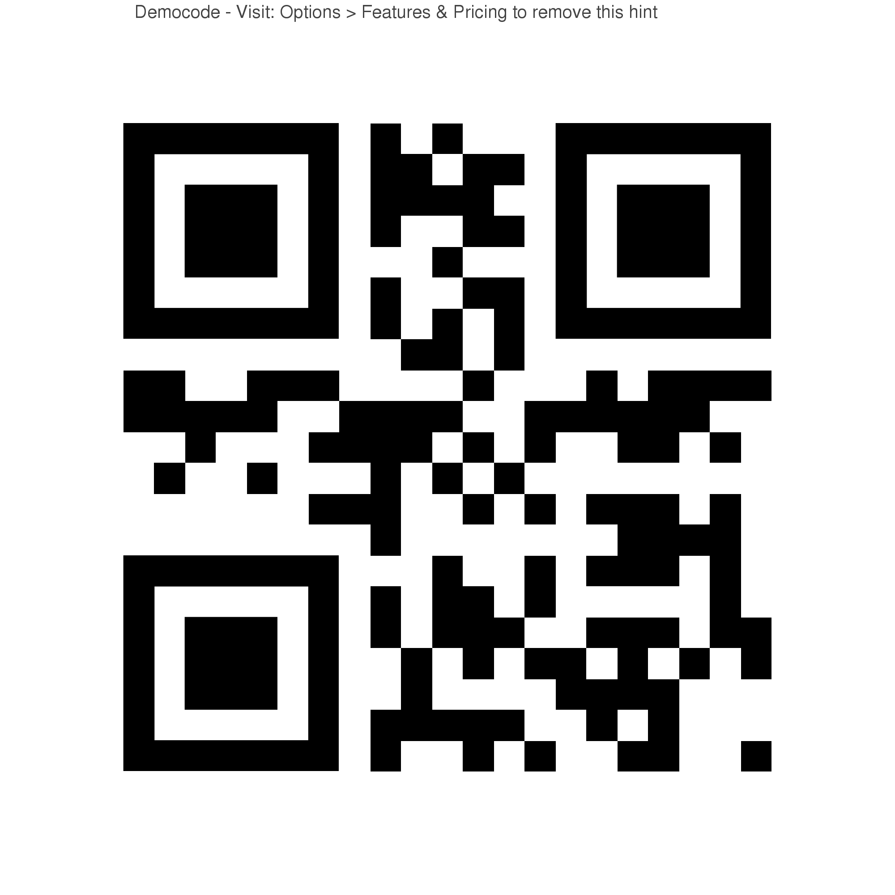
Scan to get Prediction Map

Determining Importance/Analyzing

Your instructions for this station:

- Look at the Example.

- After you have finished reading “Your Life is Fully Mobile” by Nancy Gibbs, complete a Main Idea and Supporting Details mind map on the sheet provided.

- Remember that you are looking to organize the main idea of the text – it’s important not to get bogged down in minor details. Choose one main theme/idea, and pick 4 supporting details from the text.

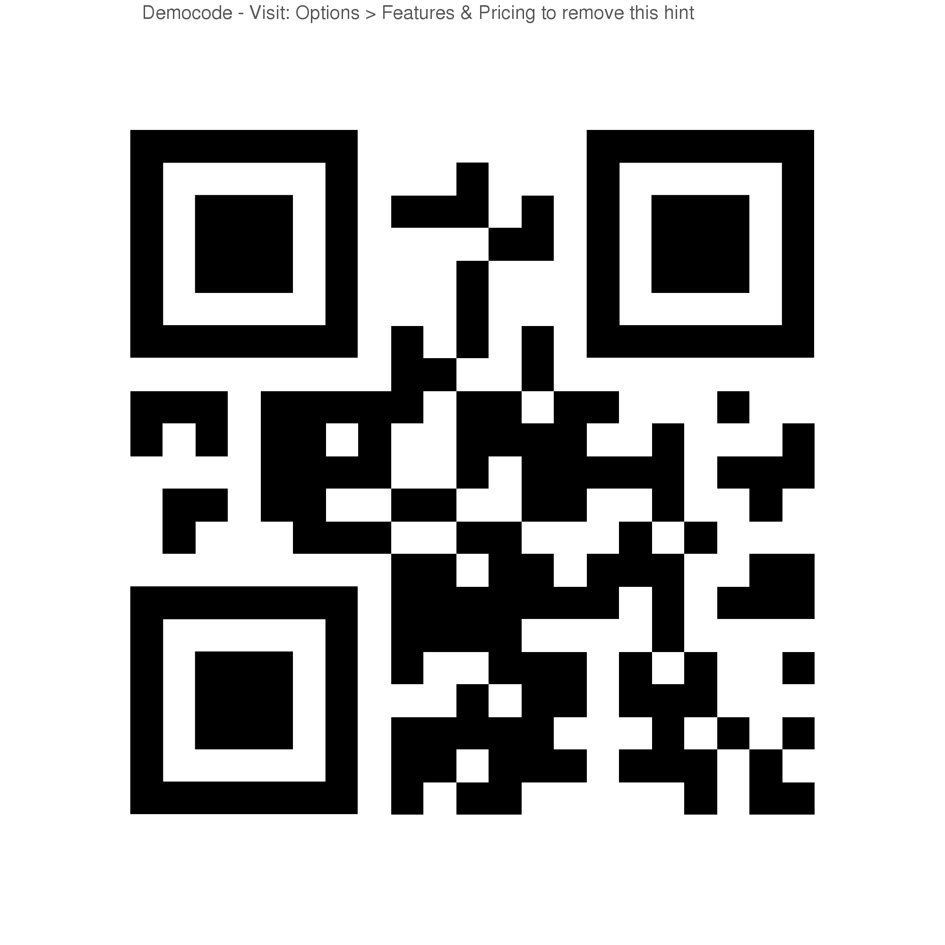
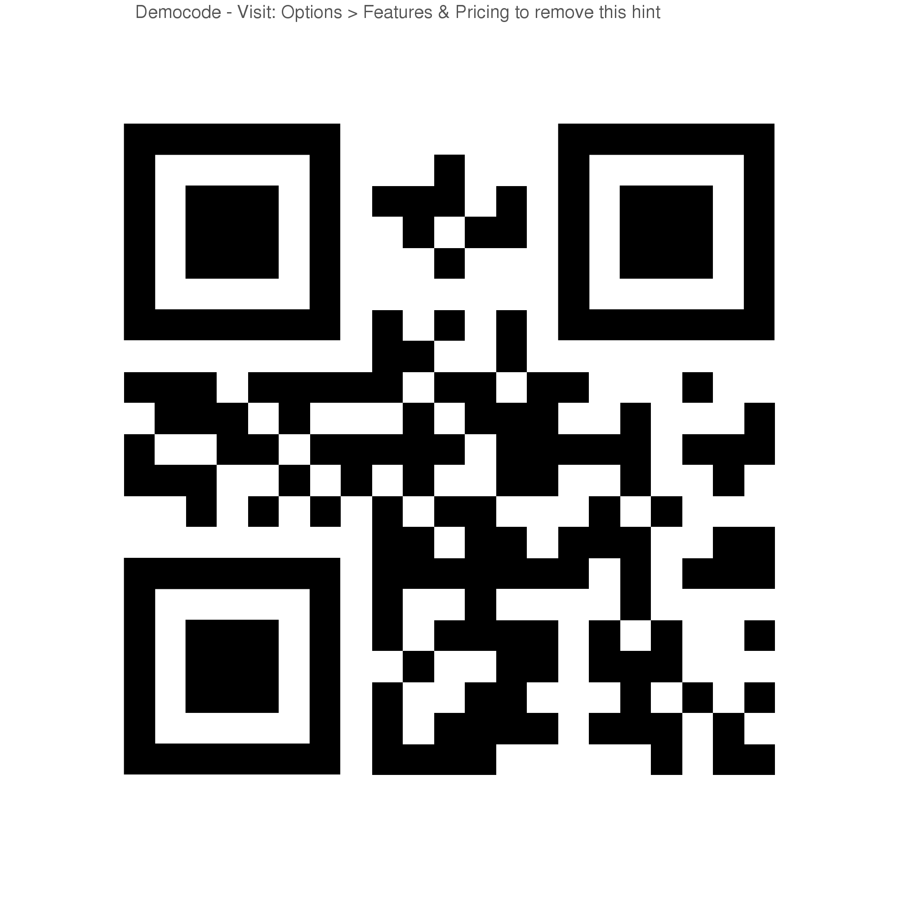

Scan for Main Idea handout Scan for “Fully Mobile” Article

Name: ___________________________ Date: _________________________

Main Idea and Supporting Details

Detail Detail

Main Idea

Detail Detail

