Art 10 – Final Project June 2015 Name: _______________________________________

All parts of the project are due on Tuesday, June16, 2015

You will have six class periods to complete this final project. All work will take place in class. This project is worth 20% of your final mark.

If you finish the project before the six days are over, you are still expected to attend class and can use that time to catch up on missed work, or to study for your other exams.

In this project you will be recreating a piece of Canadian art using the methods, techniques and mediums we have studied in this course. These are…

Elements of Art: Principles of Design:
Line Pattern
Shape Contrast
Form Emphasis
Texture Balance
Colour Proportion/Scale
Space Unity/Harmony
Value Movement/Rhythm

Methods/Techniques (How we did it):

Blending and mixing
Colour wash
Evoking emotion – Colour Theory
2 dimensional design with line
Repeating patterns - Zentangles
3 dimensional design with line, shading, value and tonality
Folding, Bending, Shaping
Creating movement in form
Perspective
Grid, Upside Down and Contour Drawing

Mediums (Materials we used):

Pencil/Eraser
Pen
Charcoal
Soft Pastels (Coloured Chalk)
Oil Pastels
Paper (Origami Folding)
Wire
Tape
Papier Mache
Paint
Food Colouring

Your reproduction must include three (3) of the above-mentioned elements, principles and techniques/methods to be completed in a (1) medium that we studied in the course.

Choose one of the following as your subject for the project:

- Autumn’s Garland, Tom Thomson
- Red Cedar, Emily Carr
- Composition, Sherman Hines
- Smears of Jam, Lights of Jelly, Mary Pratt
- Model T on Tour, Maud Lewis
- On the Nickel, Roger Golden
- Moon and Cow, Alex Colville
- “V”, Elaine Jaques
- Thunderbirds Spirit, Norval Morrisseau

Part A: Written Component – 50% of project grade – 2 classes to complete

- Complete a formal analysis of your piece of art (using Feldman’s Method), including your reasoning for picking this particular piece to recreate. /25

- Write a proposal for how you will recreate this artwork, including what medium you will be completing the reproduction in along with the 3 elements and/or techniques you will be focusing on in your work. Also include the materials you will require to do the project and how you will use your time to complete the sample.
A proposal shows careful consideration of the subject, effort made to sketch out the main idea, even if the completed project differs somewhat from the rough draft. /25

Part B: Reproduction – 50% of project grade – 4 classes to complete

Composition | Well balanced, thoughtful design of the whole. Full use of surface area. Unity and thoughtful planning. | /10
Thought and Detail | Creative, interesting, appealing. Obvious effort to make an appealing, artistic project. | /10
Use of medium | Careful use of medium… pencil, paint, pastel, paper, charcoal, mache etc. Careful choice of color, method, style. | /15
Effort | Completion of all parts of the assignment as identified in outline. Dedication to task is evident. Good use of class time. | /15

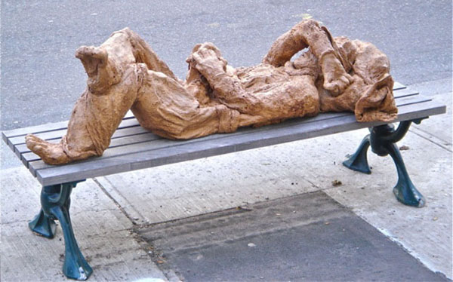

On the Nickel, Roger Golden

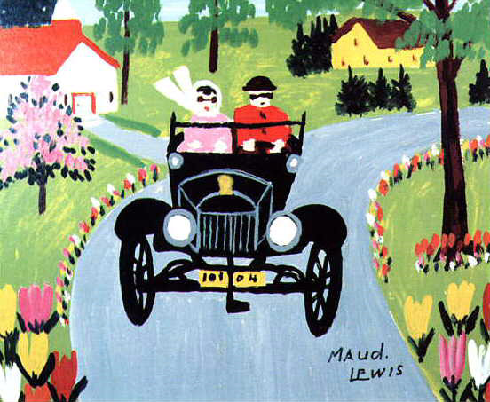

Moon and Cow, Alex Colville

Autumn’s Garland, Tom Thomson

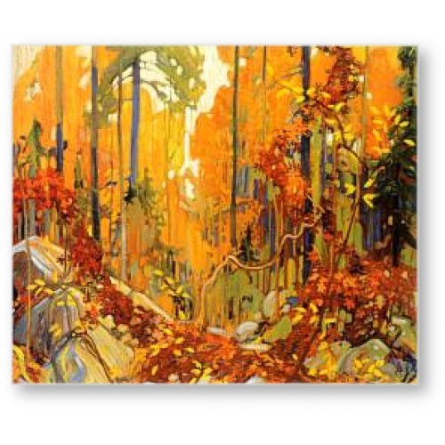

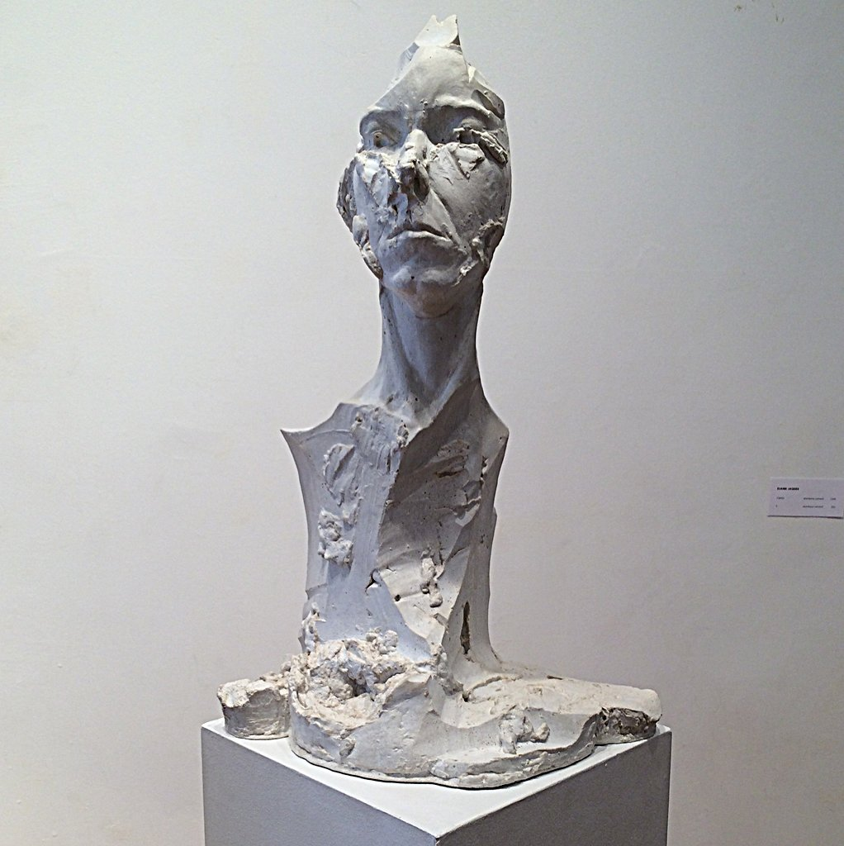

“V”, Elaine Jaques

Thunderbirds Spirit,
Norval Morrisseau

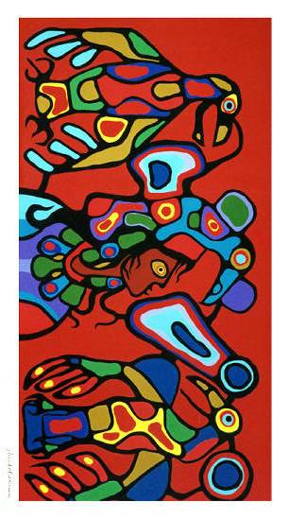

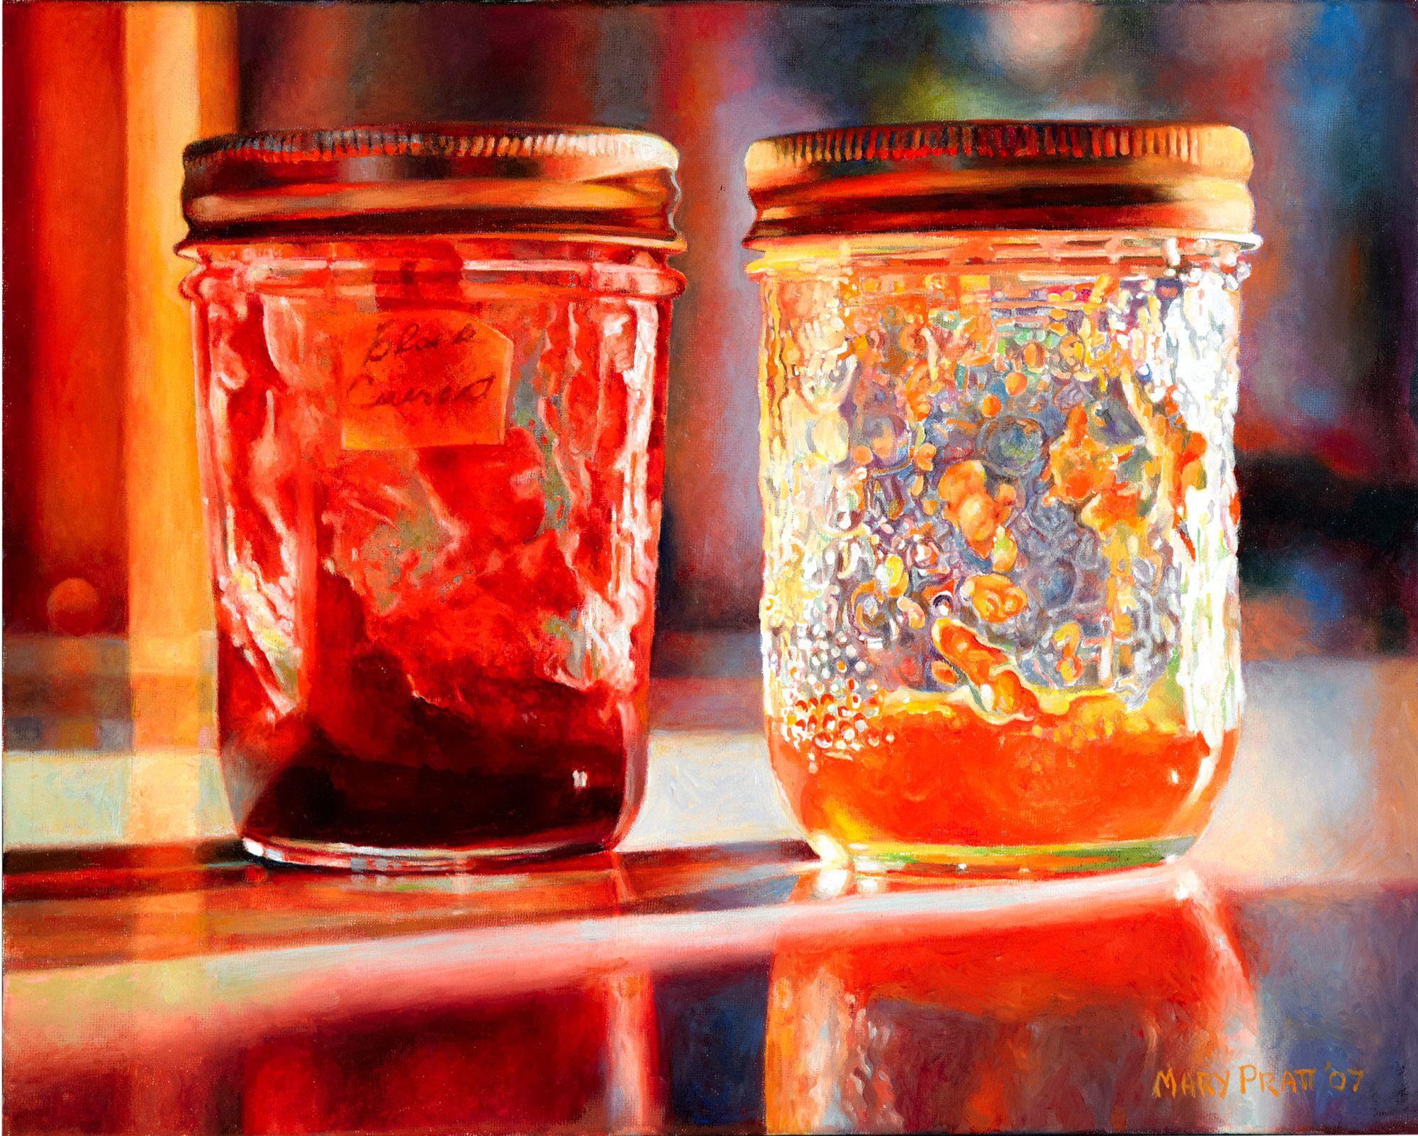

Smears of Jam, Lights of Jelly, Mary Pratt

Model T on Tour, Maud Lewis

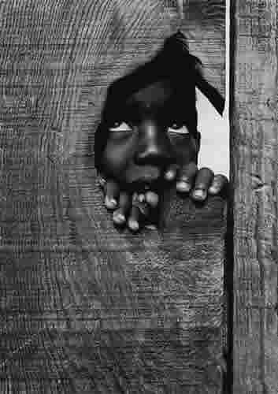

Composition, Sherman Hines

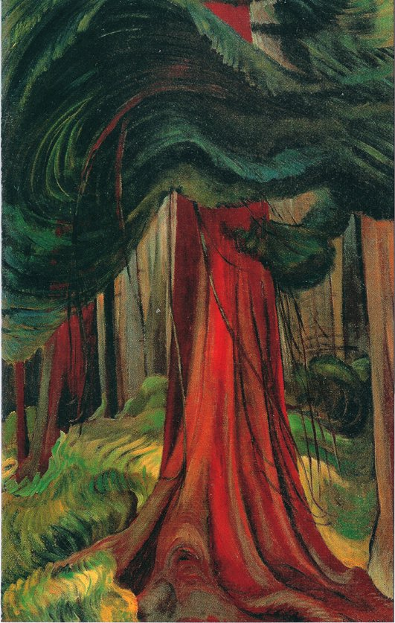

Red Cedar, Emily Carr

